BT305 Lab Assignment 6

# Name: Vansh Roll no. 210106082

**Model 1: Major Cold shock protein from Staphylococcus aureus**

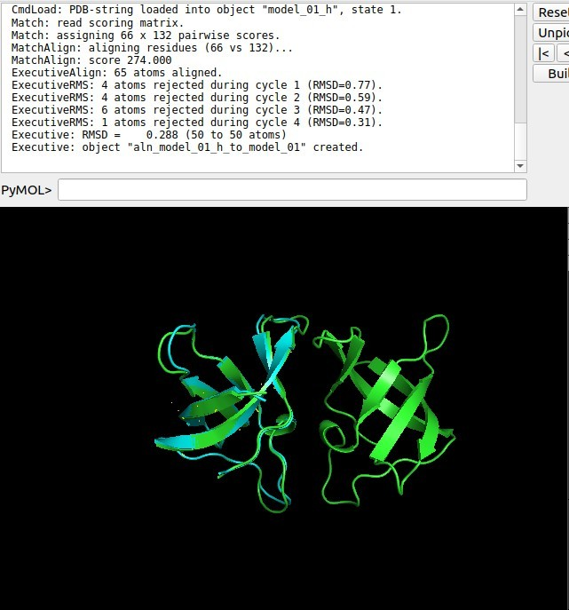Comparison between original sequence and homologue(RMSD:0.288)

Comparison between original sequence and ModWeb(RMSD:1.173)

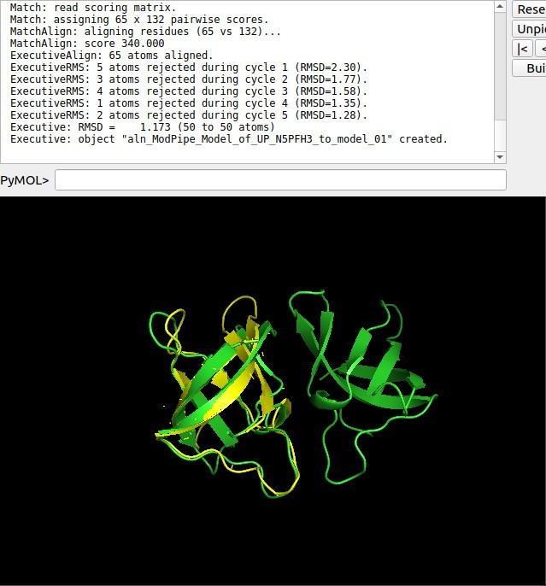

Comparison between homologue and ModWeb(RMSD:0.848)

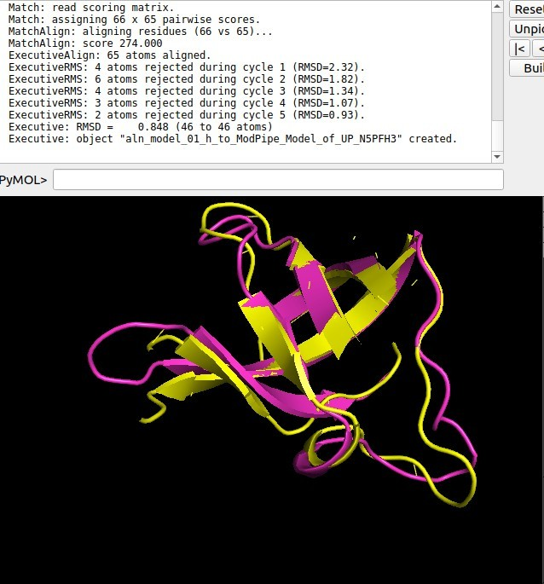

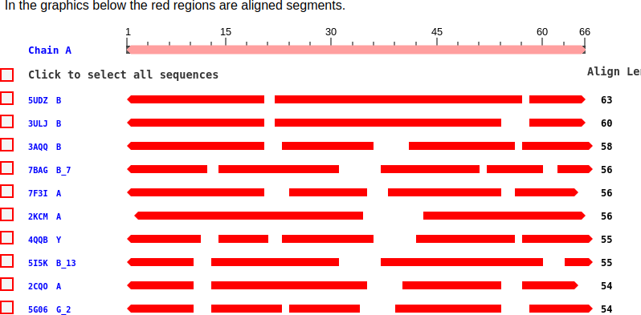VAST

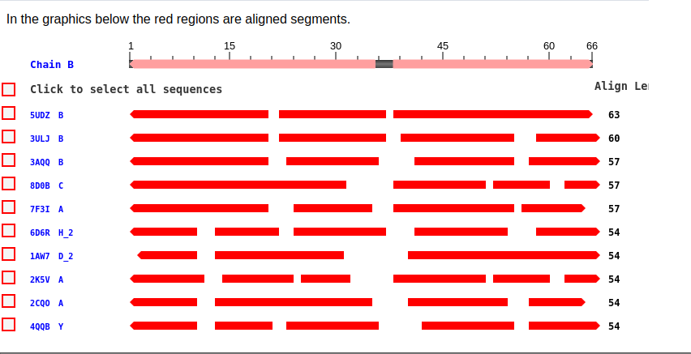

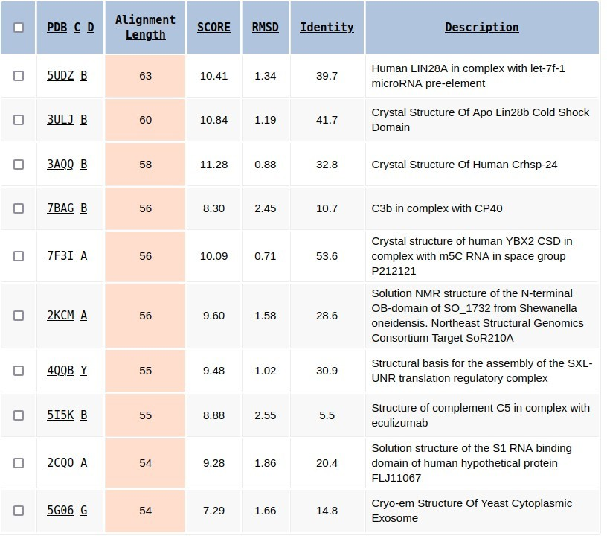

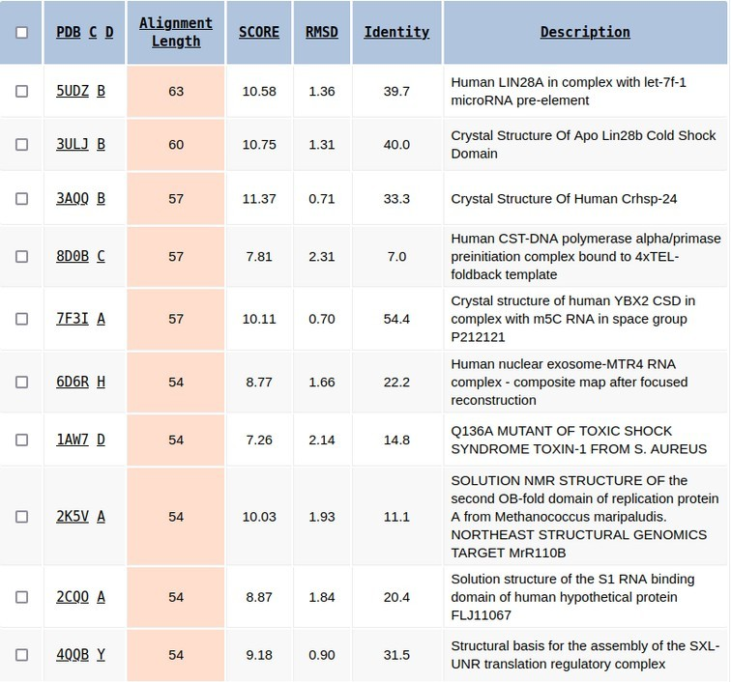

# Model 2: Antifreeze protein from Pachycara brachycephalum

Comparison between original sequence and homologue(RMSD:0.840)



Comparison between original sequence and ModWeb(RMSD:0.010)

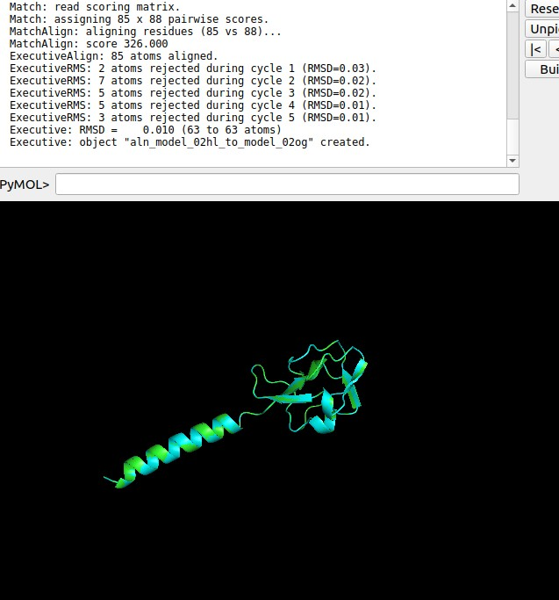

Comparison between homologue and ModWeb(RMSD:1.335)

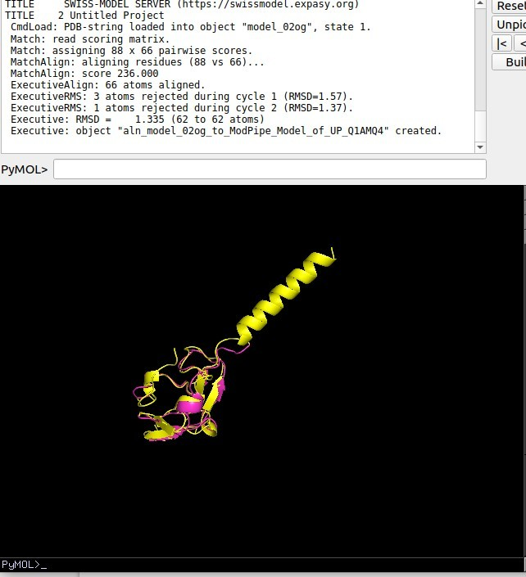

VAST

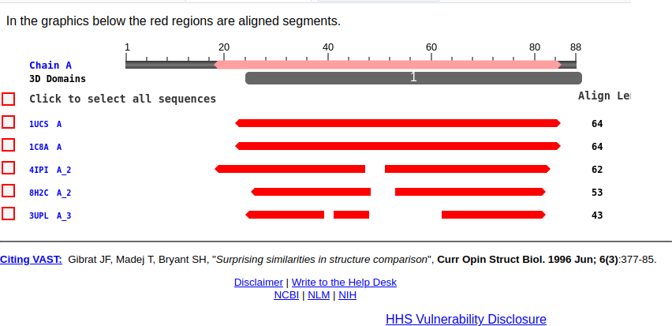

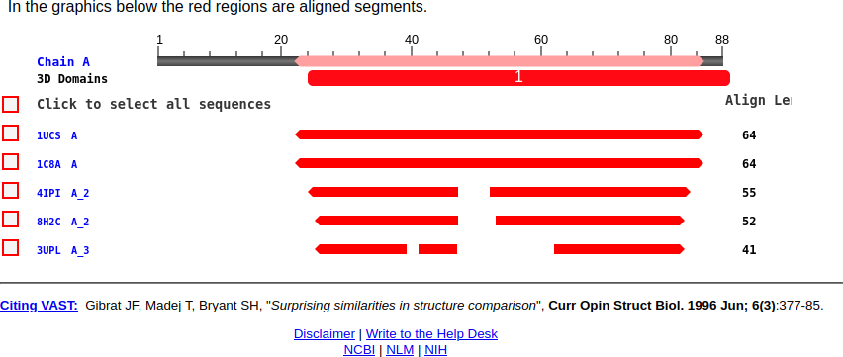

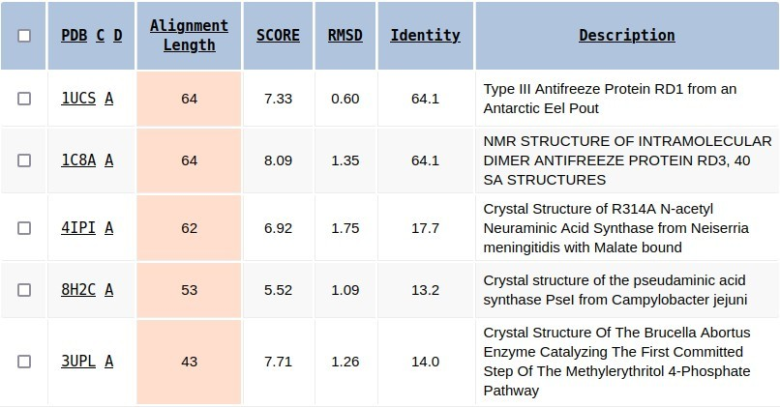

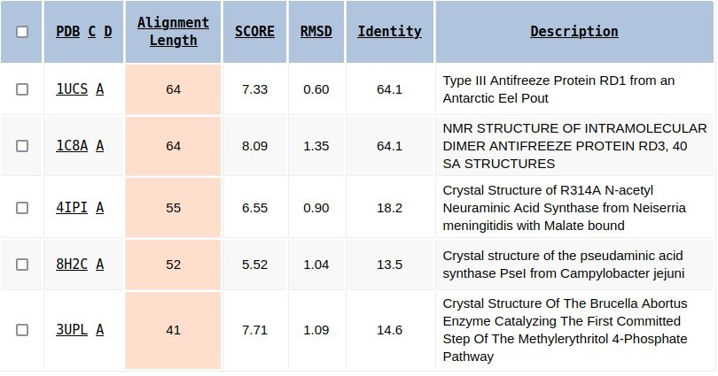

# Model 3: Dihydrofolate reductase from Vibrio cholerae

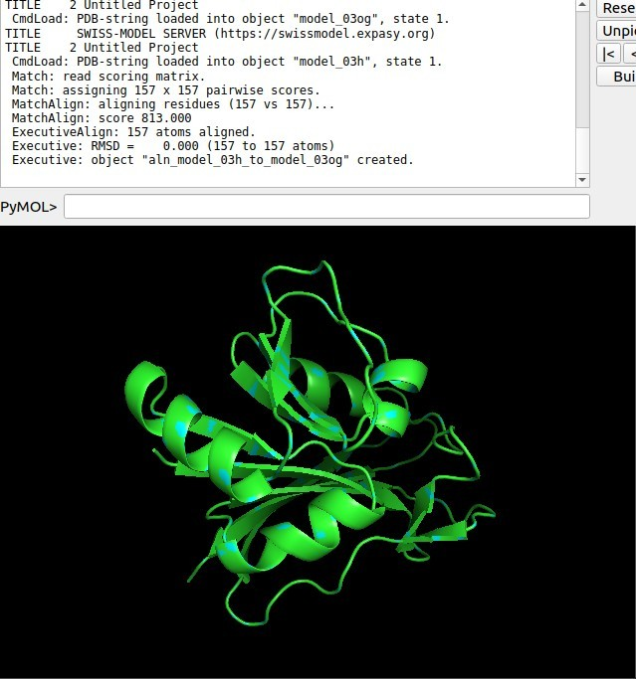Comparison between original sequence and homologue(RMSD:0.0)

Comparison between original sequence and ModWeb(RMSD:0.383)

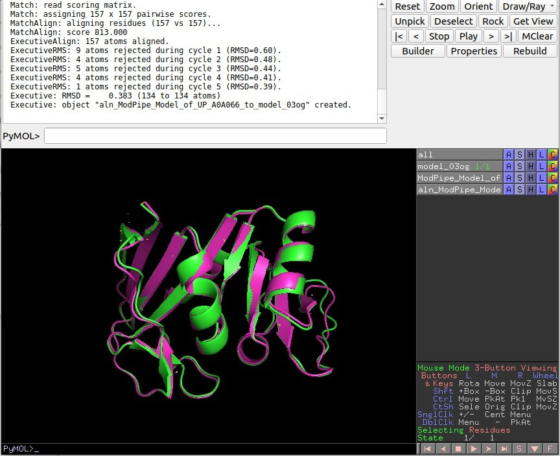

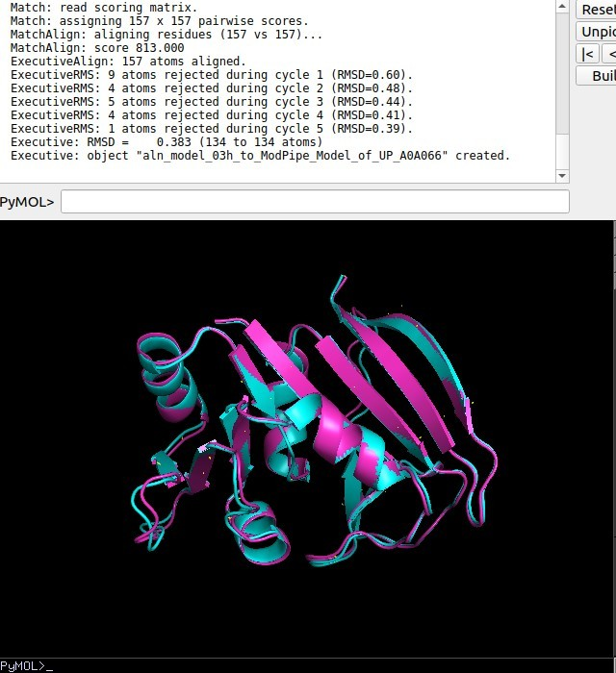Comparison between homologue and ModWeB(RMSD:0.383)

VAST

